Childhood Apraxia of Speech (CAS)

Free Advanced Training Workshop

Featuring Edythe Strand, PhD, CCC-SLP
April 6th-7th

University of Kansas: Edwards Campus

The KU/KUMC Intercampus Program in Communicative Disorders is hosting a FREE advanced training workshop by Dr. Edythe Strand, Ph.D. for speech-language pathologists who want to develop clinical skills in treatment of childhood apraxia of speech using evidence-based treatment methods. This unique, two-day workshop will include demonstrations of treatment techniques, videos, case studies, and treatment planning/goal writing activities to help participants improve their clinical skills. This workshop is limited to 50 participants in order to provide an interactive learning experience.

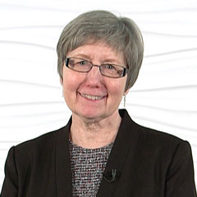 Edythe Strand, Ph.D, CCC-SLP
Dr. Edythe Strand is an emeritus Professor in the Mayo College of Medicine and former Head of the Division of Speech Pathology, Department of Neurology at the Mayo Clinic, in Rochester, Minnesota, and internationally recognized for her expertise in childhood apraxia of speech. Dr. Strand’s research has focused on developmental, acquired and progressive apraxia of speech, and issues related to intelligibility and comprehensibility in degenerative dysarthria. She has a long history of clinical experience, including the public schools, private practice, and hospital and clinic settings. Dr. Strand developed the Dynamic Temporal and Tactile Cueing (DTTC) approach for CAS treatment, which was found to be one of two motor-based treatment approaches with sufficient evidence for clinical use (Murray, et. al., 2014). Dr. Strand’s publications include many articles and book chapters related to motor speech disorders. She is the co-author of the books: Management of Speech and Swallowing in Degenerative Disease; Clinical Management of Motor Speech Disorders in Children and Adults; and is Co-editor of the book, Clinical Management of Motor Speech Disorders in Children. She is an ASHA Fellow and has been awarded Honors of the Association of the American Speech-Language and Hearing Association.

Workshop Learning Objectives
As a result of this presentation the participant will be able to:
1. Describe and demonstrate the key components evidence-based treatment for CAS, including principals of motor learning (PML)
2. Demonstrate skills in writing diagnostic statements and specific goals for children with CAS at various levels of severity, and with different co-existing deficits
3. Identify appropriate, individualized therapy targets that facilitate motor learning and support functional communication and language development
4. Understand how to implement DTTC with various age groups, including very young children with suspected CAS
5. Explain characteristics, evaluation results, and treatment strategies to parents and caregivers of children with CAS to help them understand the nature of the disorder and actively engage in treatment.

Continuing Education Information

This two-day workshop will be submitted for continuing education credit from ASHA (approval pending). Participants will receive 1.25 hours of continuing education credit for completing the entire two-day workshop. Additionally you will receive CEUs for the 5 hour webinar completed before the workshop. No partial CEU credit will be provided.
This workshop is supported through a grant from the Once Upon a Time….Foundation.
Financial: Dr. Strand receives royalties from Thieme for her written literary work, and receives a stipend from the Once Upon a Time...Foundation for presenting this course.
Non-financial: Dr. Strand is a member of the Professional Advisory Board for the Childhood Apraxia of Speech Association (CASANA).

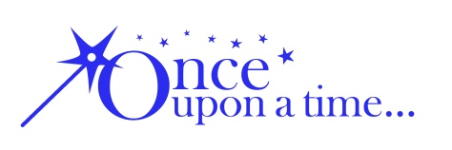

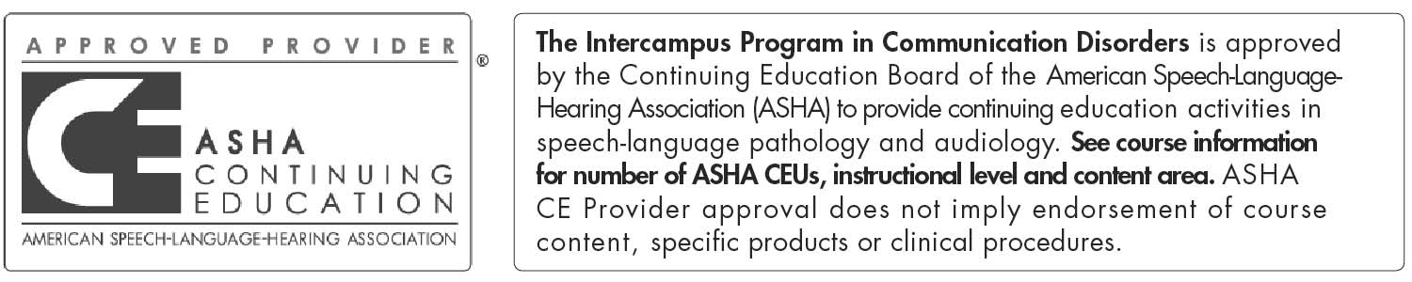

Application Process
This FREE two-day advanced workshop is only available for those who:
- watch the online video prerequisite,
- pass the video post-test with 80% or better score,
- apply to attend this workshop
- are selected to participate.
You must apply and be accepted to attend.
(See details and application below.)

_______________________________________________________________________________
50 workshop participants will be chosen from a variety of work settings, including ECI, schools, universities, hospitals, clinics, and private practice. In order to apply to attend the workshop, you must:
- Have a current Certificate of Clinical Competence from ASHA and at least 2 years of clinical experience.
- Watch the online video presentations by Dr. Strand, which covers the basics of CAS (approximately 5 hours in length) and score at least 80% on a 25-question post-test to assure that you have the essential knowledge to engage in application-based learning activities at an advanced level. (See application and directions below.)
- Complete the application to attend the workshop, including a 1-page Statement of Intent describing how you will utilize the information. In the event that the number of applicants exceeds available space, selection decisions will be based on the applicant’s statement of intent and representation of participants across the continuum of care (ECI, schools, medical facilities, clinics, etc.). Completing the application does not guarantee acceptance to the workshop.
- Agree to attend the full two-day workshop and complete the pre-requisite course readings (4 journal articles).

How to Access the Online Video and Post-Test
- Send an email to CASonline@utdallas.edu with your name and ASHA number.
- Receive a reply message with online login information.
- Once you have received your log in information, you will be directed to the videos. You may view the videos as many times as you wish; however, you may only access the post-test one time. The post-test contains 25 randomly ordered questions and is timed limited to 40 minutes. At the end of the post-test you will receive a certificate that documents your score. You will use this to apply.

How to complete the Workshop Application
Instructions:

Download and complete the application (see below). Scan the completed application form and submit with the Statement of Intent and video completion certificate as an e-mail attachment by March 16th.
You will receive an e-mail confirming your application was received. If you do not receive an e-mail, it is your responsibility to re-contact us within 24 hours of the deadline to assure that your application was received.

All applicants will be notified of selection decisions by March 24th.
Submit the application form and narrative to: gso.splh.clp@gmail.com

CAS Advanced Workshop Application

Name:___________________________________________________________________

Address__________________________________________________________________

E-mail___________________________________________________________________

Educational degree_____________________Year received_________Current CCC? Y N

Employer:_____________________________________________________________

Position:_________________________________________________________________

Employment setting: _____private practice _____for-profit organization _____not-for-profit
_____other (describe)__________________________________________________________

Please attach the following items to your application:
- A copy of the online video post-test certificate. Must score at least 80%.
- A Statement of Intent describing why you are interested in attending this workshop and how you will utilize this information in your clinical practice. Please include details about how you will implement the knowledge and skills acquired in this workshop to help students or colleagues further their understanding of CAS treatment and/or how you might serve as a resource for CAS. The statement of intent should not exceed one page.

I confirm that I have viewed the entire online video and understand that I am applying to attend the workshop. Because of space limitation, my application will be reviewed and applying does not guarantee acceptance to the workshop.

_____________________________________
(Signature)

This application is due March 16th
Submit the application form, post-test certificate and narrative to: gso.splh.clp@gmail.com

